On June 21, 2018, the U.S. Supreme Court ruled in Pereira v. Sessions in favor of Wescley Pereira, a Brazilian immigrant, in a significant recent decision that opens new options to apply for relief from deportation. In the 8-1 opinion, the court decided that if an undocumented immigrant's “notice to appear” in immigration court does not include the specific time or place of the non-citizen's removal proceedings, then the notice is invalid. This change can help aliens in current or past removal proceedings by extending relief to those who have been served defective “notices to appear” in immigration court.
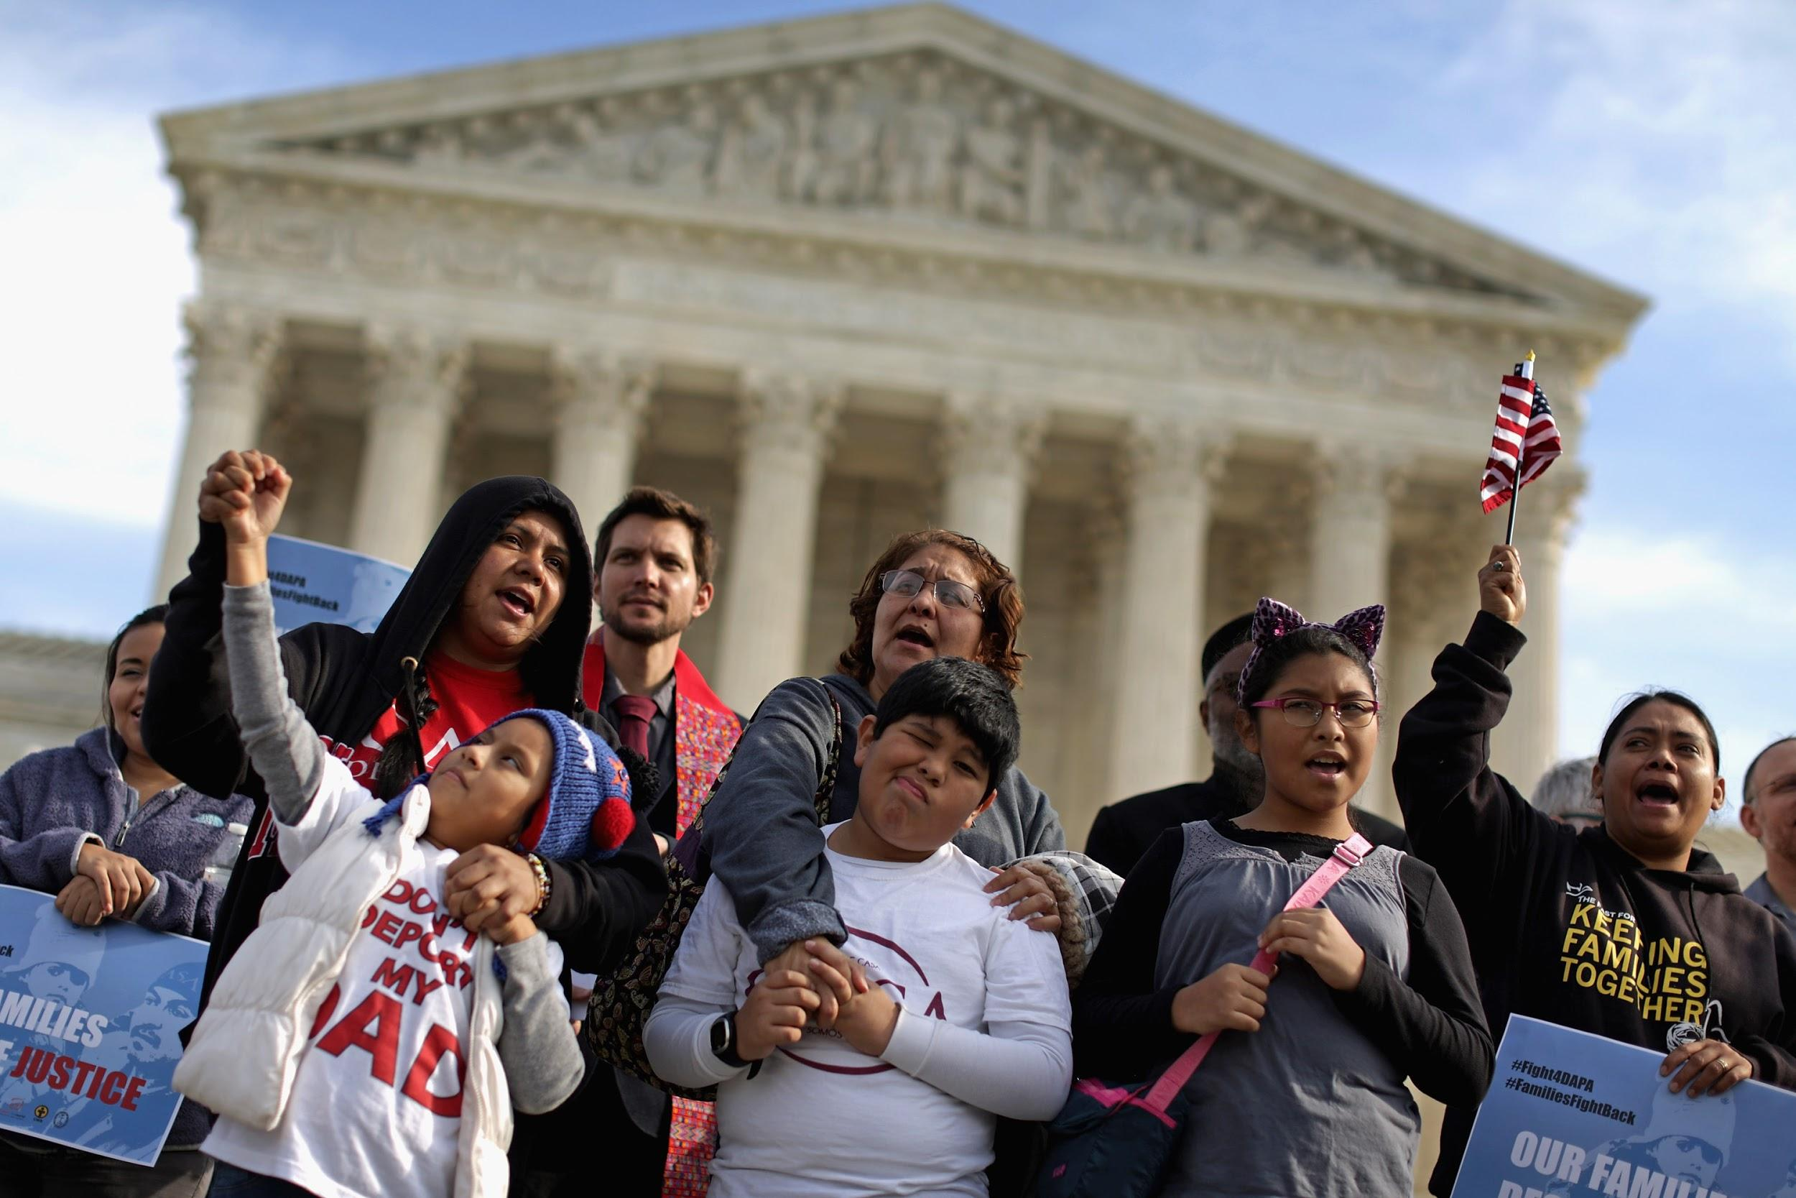
This decision is especially impactful when applied to 8 U.S.C. § 1229b(b)(1), the Cancellation of Removal Provision, which grants the attorney general discretion to cancel the removal of a non-permanent resident alien who is inadmissible or deportable from the United States if the alien meets certain criteria. According to USCIS, the criteria for deportation cancellation includes a continuous physical presence in the United States (ten years for nonpermanent residents, seven for lawful permanent residents). However, this continuous period ends when the alien is served a “notice to appear” for removal proceedings, otherwise known as a “stop-time” rule.

After the Pereira decision, an unauthorized immigrant's "continuous physical presence," required for removal cancellation, does not stop upon the receipt of a defective “notice to appear.” According to Justice Sotomayor, “the “essential function” of a notice to appear is to inform noncitizens, to notify them, of when and where they are to appear for removal proceedings. If no time or location is explicitly stated, the noncitizen cannot be reasonably expected to appear for their removal proceedings. Without a time and date, a notice is not considered merely incomplete, but is indeed not a notice to appear at all.”

According to the Oyez Project, an archive of the Supreme Court at the Illinois Institute of Technology's Chicago-Kent College of Law, Wescley Fonseca Pereira entered the United States in June 2000 as a non-immigrant visitor authorized to stay until December 21, 2000. Pereira overstayed his visa, and in May 2006, the Department of Homeland Security (DHS) served him with a notice to appear for a removal hearing that did not specify the date and time of his initial removal hearing. When the immigration court set a date and time, it mailed Pereira a notice with the information, which Pereira never received. When Pereira did not appear for his removal hearing, an immigration judge ordered him removed in absentia.

Pereira was not removed and in March 2013, he was arrested for a motor vehicle violation and detained by DHS. Through his attorney, Pereira filed a motion to reopen his removal proceedings, claiming he had never received the hearing notice with the time and place, and sought relief in the Cancellation of Removal Provision. The Supreme Court ruled in favor of Pereira’s claim that because he did not receive notice of the time and place of his removal hearing, his presence in the country was continuous and over ten years, satisfying one of the criteria in the Cancellation of Removal Provision.

As a result of this decision, eligible immigrants living in the country without authorization who have received defective "notices to appear" can apply for a cancellation of removal using a Pereira motion. Additionally, immigrants who had previously not considered or have been denied cancellation of removal waivers because of ineligibility can explore new options to terminate removal proceedings started with a defective “notice to appear” or reopen their cases.

Attorneys have recently begun to file Pereira motions, though it is uncertain how courts will interpret the Supreme Court ruling. One major question is whether the ruling will only apply to those who have been in the country long enough to ask that their deportations be suspended, or whether there is potential for larger implications for immigration law.

Justice Sotomayor elaborates in the ruling that it is unimaginable as to why the Department of Homeland Security and the immigration courts could not work together to schedule hearings before sending the notices to appear, given today’s innovative technologies. As such, the Pereira ruling could potentially demonstrate a new legal trend toward preventing governmental ineffectiveness in the field of immigration.

The new Pereira motion opens new options for the security of immigrants. If you have received a defective “notice to appear” in immigration court (one without a specified time and place), contact The Law Office of Elektra B. Yao for guidance.

