Michelle Chen Shakespeare’s Global Afterlives
12/21/17 Archiving Global Shakespeare
Part 3 Sections A-D
Catalogue Descriptions and Analysis
The Tragedy of Othello, The Moor of Venice
Directed by Orson Welles
Written by William Shakespeare
1952/USA/Italy/Morocco/France
Mercury Productions/Les Films Marceau
European Premier Release Posters
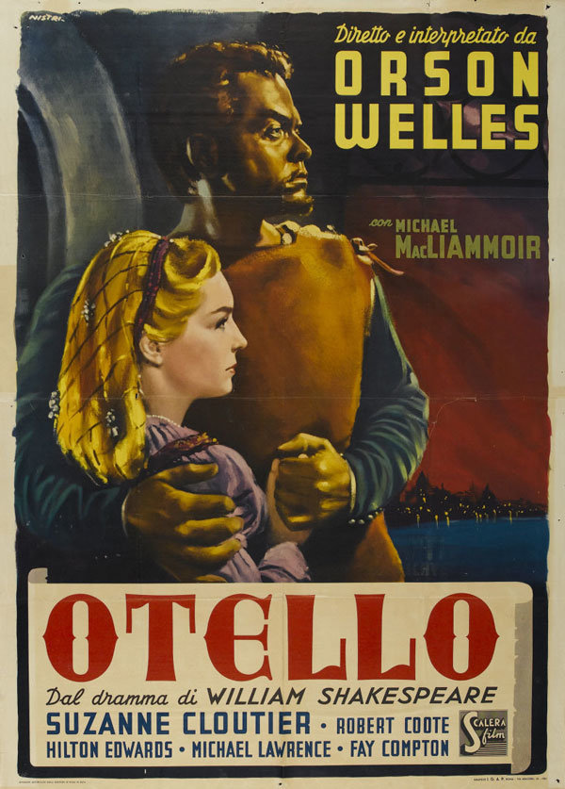
Italian poster for Othello (Orson Welles, Morocco/Italy﻿, 1952) by Enzo Nistri﻿﻿﻿
https://mubi.com/notebook/posts/movie-poster-of-the-week-orson-welles-othello-and-shakespeare-on-film
- First-ever premiere, used in Rome, Italy with dubbed version: original English-language version premiered at the fifth Cannes International Film Festival in 1952, tied for grand prize with all-French jury.
- Located on Mubi, a film website with a subscription video service, database, and online magazine known as the Notebook, as a Notebook feature article.
- Composition: Focus on Othello and Desdemona as a couple, both faces in profile and Othello seems dominant and controlling: Othello is an entire head taller than Desdemona and is holding her tightly. Both are looking intently at something out of sight with a dark sunset or sunrise background over water, and against part of a building and archway.
- Color scheme: Othello’s skin and body look gold and metallic, but Desdemona’s hair is the brightest gold. Othello looks darker and Desdemona looks brighter than in the movie. There is a moody red and black sunset, and the whole poster looks dark and imposing.
- Image choice: Othello appears to be wearing leather armor and Desdemona’s wearing a purple pastel dress: violence versus romance?
- Font: Boldest font is the abbreviated title for the movie (“Otello” when the full movie title is The Tragedy of Othello, the Moor of Venice) and Orson Welles’ name. Next largest font is supporting actors such as those for Iago and Desdemona and acknowledging Shakespeare. Smallest font (the only one without all capital letters) is for other actors, other words, and the production company.
- Analysis: A bold and colorful poster: the realistic illustration of Desdemona and Othello allows us to see them in color in what is a black and white film. Moody and tragic expressions on characters as they gaze toward a dramatic sunrise or sunset emphasizes the blending of romance and tragedy. Othello has a skin tone that seems more suited to a statue, and he towers over Desdemona: the height difference is accurate as in the film, but Othello’s skin tone is exaggerated, possibly to show how Welles breaks with “bronze age” film and play depictions of Othello as not black but with more of a Middle Eastern skin tone. Othello appears hulking, dark, and almost alien clutching the very white Desdemona. As the first poster for the movie, Shakespeare is clearly accredited, which may be because the film hasn’t built up a reputation as uniquely Orson Welles’s story yet because of his breakings with Shakespearean tradition.

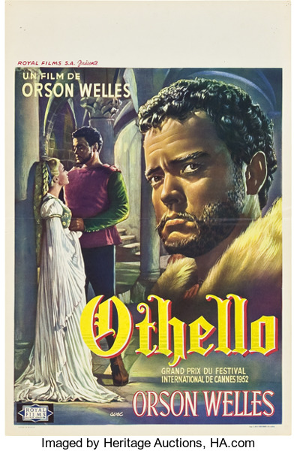
Othello (Royal Films, 1952). Belgian Poster
https://movieposters.ha.com/itm/drama/othello-royal-films-1952-belgian-14-x-22-/a/7008-86051.s?ic4=GalleryView-Thumbnail-071515
- Used for Belgian release in 1952, mentions Cannes Film Festival award
- Located on Heritage Auctions website for 2009 July Signature Vintage Movie Poster Auction #7008
- Also seen on official Festival de Cannes website, used as main poster for 1952 festival
- Composition: Othello is a large figure in the foreground, looking at somewhere in the high distance. The background has Othello and Desdemona standing together inside a building with arches but not holding each other as tightly as in the Italian poster.
- Color scheme: Much cooler colors than the Italian poster, characters featured on the poster are indoors and appear entrapped inside a claustrophobic space. Othello is wearing purple and green when holding Desdemona, who is in a white, possibly bridal dress. The large image of Othello in the foreground looks pensive and suspicious as if he is thinking of him and Desdemona in the background image, and he appears to be wearing fur which seems to emphasize his status or military career. Othello has pale brown skin that has a natural tone, which contrasts with Desdemona’s white dress when he holds her.
- Image choice: The focus is on Othello gazing past the audience with a suspicious or sorrowful expression in what looks like a scene where Othello begins to be manipulated by Iago. Desdemona is wearing a white, flowing dress, which she does during the moments during the film when Othello is the happiest about their relationship. There is more insight into the costume colors as the film is black and white.
- Font: Largest font spells out “Othello” and “Orson Welles,” with no supporting actors listed. Orson Welles is emphasized as it is on the poster twice, and this is the first poster with the Cannes film festival award. There’s no credit given to Shakespeare.
- Analysis: While in the first Italian poster there seems to be a unification of romance and violence, in this one it looks like a struggle between Othello’s warring and loving selves. Othello seems to be remembering the background scene of him and Desdemona being happy together. Again, the poster is bold and colorful, but has a much cooler and brighter color palette, which contrasts with the mostly dark atmosphere in the film. The white interior of the building makes the setting appear much less claustrophobic than in the film, and Othello’s skin color appears darker on this poster. This may emphasize Welles’ innovation of playing Othello in clear blackface rather than in the “bronze age” tradition. This is also the first poster where Shakespeare isn’t accredited at all but the Cannes film festival award is: this may show how Shakespearean tradition diminishes in importance as Welles’ film builds up an audience who recognize it as innovative and un-Shakespearean. Therefore, this poster suggests the beginnings of the Othello story in this film as solely belonging to Welles.

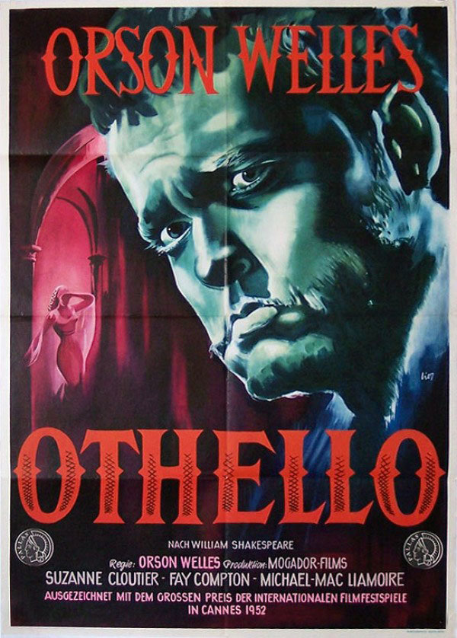

German poster for Othello (Orson Welles, Morocco/Italy﻿, 1952) by Lier.
https://mubi.com/notebook/posts/movie-poster-of-the-week-orson-welles-othello-and-shakespeare-on-film
- Used for German release in 1955, mentions Cannes Film Festival Award
- Composition: Othello looms large in the foreground, gazing through the viewer, while in the background a woman who may be Desdemona based on the plaited hair but who may represent other women in the play, is a tiny figure with few details. The composition is very dramatic as Othello is the only one whose facial features are focused on, and the main focus of the woman is her body shape and dramatic pose. The woman also appears to be very far away from Othello and the audience, deep inside claustrophobic corridors.
- Color scheme: Red and blue are the main colors of the poster even though the film is black and white. Othello is blue-tinted, which may symbolize male logic in opposition to the red-tinted woman and background, which may demonstrate passion, emotion, and anger. The title and director are also in red letters, which might show how passion takes over Othello and the play, just as how red is shown to define the poster in the main lettering.
- Image choice: Othello’s emotions are the focus as his face takes up more than half of the poster, and he appears like a tragic figure, displaying sadness and confusion as he looks toward the audience. The female figure in the background is…as shown in the movie
- Font: The largest, red font is “Othello” and “Orson Welles”. In much smaller font, Orson Welles is listed again, the only one to be in the same color font as the mention of the Cannes film festival prize, and there are three supporting actors and the film company listed as well. The smallest font are the words accrediting Shakespeare.
- Analysis: One of the boldest and most colorful posters, the sole use of red and blue emphasizes the differences between Othello and Desdemona. Othello is blue, which is reminiscent of the cold logic of his military career and of the moment in the film when he recites the famous line that he strikes his heart and it hurts his hand. In the background is a female figure with plaited hair, most likely Desdemona from the hairstyle, and the red palette shows emotional, stereotypically female passions. There are a lot of tragic undertones to the poster in Othello’s expression and Desdemona’s posture, to the point of melodrama where the dramatic color palette is reminiscent of horror movie posters. While Shakespeare is accredited, the name is much smaller on this poster than on the first one, and the Cannes film prize is also mentioned. This indicates that after the Cannes film festival, where the first large audience of the film would have been created, the importance of Shakespeare to Welles’ narrative is drastically diminished. Welles’ film is on its way to take on a separate life of its own apart from Shakespeare.

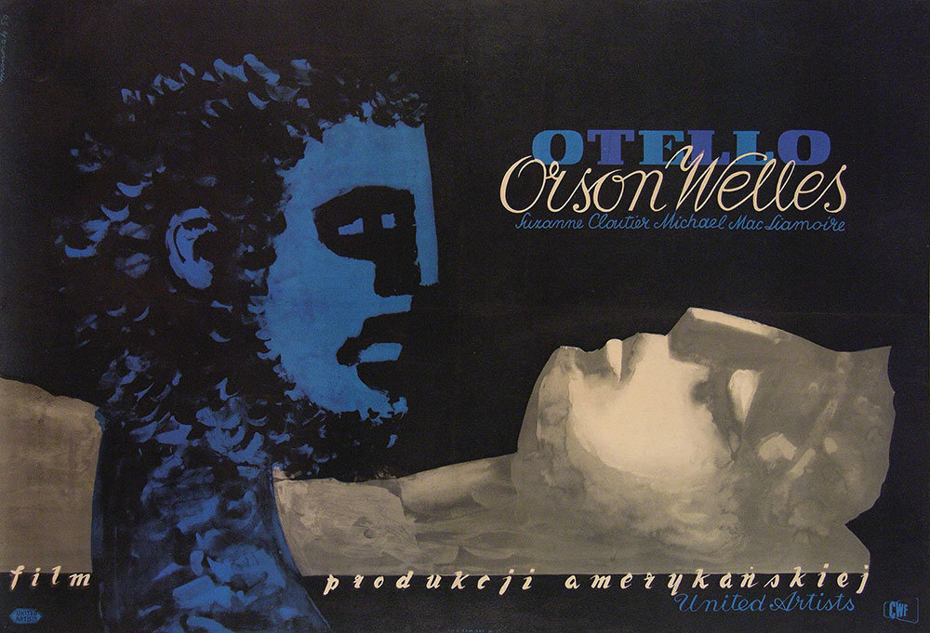

Polish poster for Othello (Orson Welles, Morocco/Italy﻿, 1952)﻿﻿﻿ by Jozef Mroszczak
https://mubi.com/notebook/posts/movie-poster-of-the-week-orson-welles-othello-and-shakespeare-on-film
- Used for Polish release in 1952
- Composition: The illustrations of the characters are very abstract: Othello is defined by his hair texture, and he is vertical, looking at a horizontal woman who has her eyes closed and appears less human and more statue-like than Othello. Both characters are defined by a single color while the background is solid, and at the point where their necks cross there may be a religious cross implied. The woman’s body appears to melt into the surface she is lying on, and both characters’ emotions are left mysterious.
- Color scheme: There are only three colors on the poster: blue, black, and gray. Othello is blue, along with the title, movie company, and supporting actor text. The woman is gray and off-white, appearing like a statue with no expression and possibly dead, sleeping, or in an altered state of consciousness from the closed eyes. The text “Orson Welles” is the same white color.
- Image choice: The only moment in the film when Desdemona is lying down and has her eyes closed is when Othello approaches her to murder her, and the usage of different colors for Othello and Desdemona shows their growing differences. However, both characters’ expressions are unreadable due to the abstractness of the poster illustration, unlike in the film.
- Font: The largest font is “Otello,” which is blocky and all capital letters in alternating shades of blue, and “Orson Welles,” in a loopier and more elegant script. The next smallest text is the production company, and the smallest text is two supporting actors. There is no attribution to Shakespeare.
- Analysis: In this poster, Othello has dominance and control over the prostate Desdemona, during the film scene when Othello approaches her to strangle her. Again, the usage of blue shows Othello’s coldness and logical resolve such as when he states that he strikes his heart and it hurts his hand. Desdemona is clearly objectified as she appears unconscious and statue-like, though in the film it is shown that she only pretends to be asleep when Othello is approaching her. Othello is defined by his hair texture, which is very exaggerated from how Othello appears in the film, possibly demonstrating Welles’ decision to use blackface instead of a “bronze age” Middle Eastern skin color as an innovation that will draw in audience interest. Shakespeare is again not accredited on this poster, showing that the draw to audiences isn’t Shakespeare but Orson Welles usurping Shakespeare’s story. This may show that for audiences, the main draw for a famous Shakespearean play is how the director diverts from Shakespeare’s vision in the text and innovates.

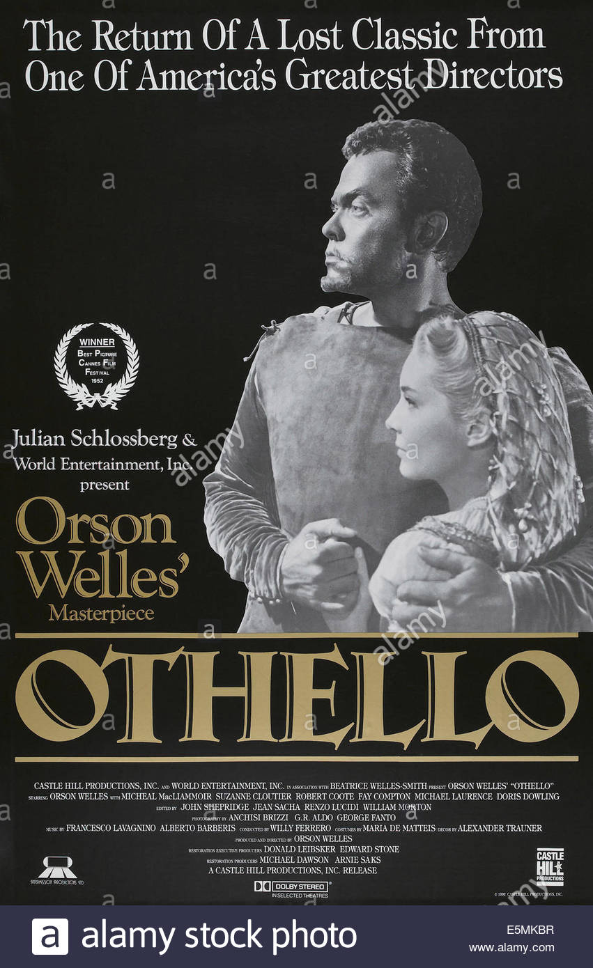
U.S. and International Re-Release Posters

OTHELLO, (aka THE TRAGEDY OF OTHELLO: THE MOOR OF VENICE), 1992 US re-issue poster, from left: Orson Welles, Suzanne Cloutier, 1952
http://www.alamy.com/stock-photo-othello-aka-the-tragedy-of-othello-the-moor-of-venice-us-re-issue-72369019.html
- Used for first re-release with clearer, edited audio from the original
- Composition: First poster with a shot from the movie: a black-and-white cutout of Othello holding Desdemona tightly, both of them appearing to look at the same thing towards the left off screen. They are between two large pieces of text, “Othello” and the headliner of the movie as a lost classic from a great director.
- Color scheme: The first poster without much color and very much true to the black-and-white film, the only color is in the gold text. The lack of color makes Othello’s skin color appear much lighter and similar to Desdemona’s skin tone, especially against the black background, unlike other posters where their skin difference is emphasized.
- Image choice: First screenshot from the actual movie on a poster instead of an illustration: this scene is most likely from the beginning of the film when Othello and Desdemona are enjoying their romance.
- Font: Much more text than all earlier posters: the largest text is gold and states “Othello” and “Orson Welles’ Masterpiece.” The second-largest text is the introductory line “The Return of a Lost Classic From One of America’s Greatest Directors,” which is white as is the rest of the text. The Cannes film festival award logo is prominently displayed as it is in the direction the characters are looking towards. The smallest text is the production company and supporting actors. Shakespeare is not accredited.
- Analysis: The first poster with a simple color palette, which brings back Welles’ film as a nostalgic historical relic, despite this version being the first where the sound is edited, so ironically the film wouldn’t have sounded the same in the time of its first release despite the poster trying to convince the audience that this version is vintage. Despite the heavy use of text on the poster promoting Orson Welles, the Cannes film festival prize, and all the minor actors, Shakespeare is nowhere to be seen on this poster. The “lost classic” now belongs to “Welles,” whose status is elevated to approach Shakespeare’s status as “one of America’s greatest directors” and the film is said to be “Orson Welles’s masterpiece” and not Shakespeare’s. This poster grants Welles legitimacy to take over Shakespeare’s original story and have audiences accept his innovations.
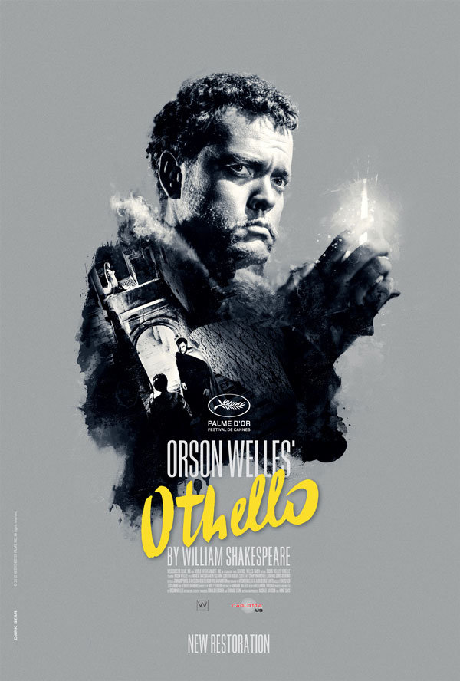
US 2014 re-release poster for Othello (Orson Welles, Morocco/Italy, 1952)﻿ designed by Dark Star, Paris.
http://www.carlottafilms-us.com/othello/
- New restoration opened in New York and Chicago in 2014, used for theater promotion 2014-2016 across the United States
- Also released in France by Carlotta Films
- Composition: Immediately appears very modern compared to previous posters, as Othello appears to be a mix of different elements. Othello’s face and hand are the centerpieces, which still appear very light in contrast with the background. He is holding a candle that appears less realistic and more of an illustration, and his upper body dissolves into what appears to be smoke and ink, framing Othello encountering a character in a stairwell while a woman is kneeling on the distant arch above them. This space seems claustrophobic but airy as there are light sources behind the archway, and the woman is illuminated in white.
- Color scheme: Simple color scheme as in the first re-release: gray, white, black, and yellow. Real images from the film are blended so at points there’s the illusion of illustration. The whitest parts of the poster are Othello’s face, the candle, his face in the smaller scene, the archway behind him, and the woman above the arch on the larger Othello’s shoulder.
- Image choice: The interior image is from Othello walking towards Emilia after he slaps Desdemona and leaves, while the main image of Othello never occurs, as he never holds a candle in the film, though the facial expression is from when Iago first begins manipulating Othello.
- Font: The largest font is “Othello,” the only word in yellow lowercase script, and “Orson Welles” in white capital letters. The medium font shows that the film is a new restoration and acknowledges Shakespeare. The production company and supporting actors are in the smallest font.
- Analysis: This poster blends previous poster traditions: the dramatic gaze and focus on Othello’s face, the heritage of both illustration and photography on the cover, the usage a of background scene, and the black and white spectrum with gold possibly hinting at Othello’s inherent nobility. The image editing makes it very modern, and Shakespeare is acknowledged, though less so than Orson Welles and the title. The major themes of this poster appear to be violence and male contemplation, as the candle only appears in the film during when Othello approaches Desdemona to kill her and he puts out three candles using the palm of his hand. On this poster, Othello is a conglomeration of elements that makes him seem powerful and somewhat inhuman, but his skin appears lighter than on other covers. This seems to symbolize Welles’ total hijacking of the Shakespearean story and character, by way of the text on the poster implying his possession of Othello through the film’s innovative retelling as well as how light Othello’s skin appears on this poster, as if accommodating Orson Welles playing Othello in the film and to placate modern audiences who are against blackface.

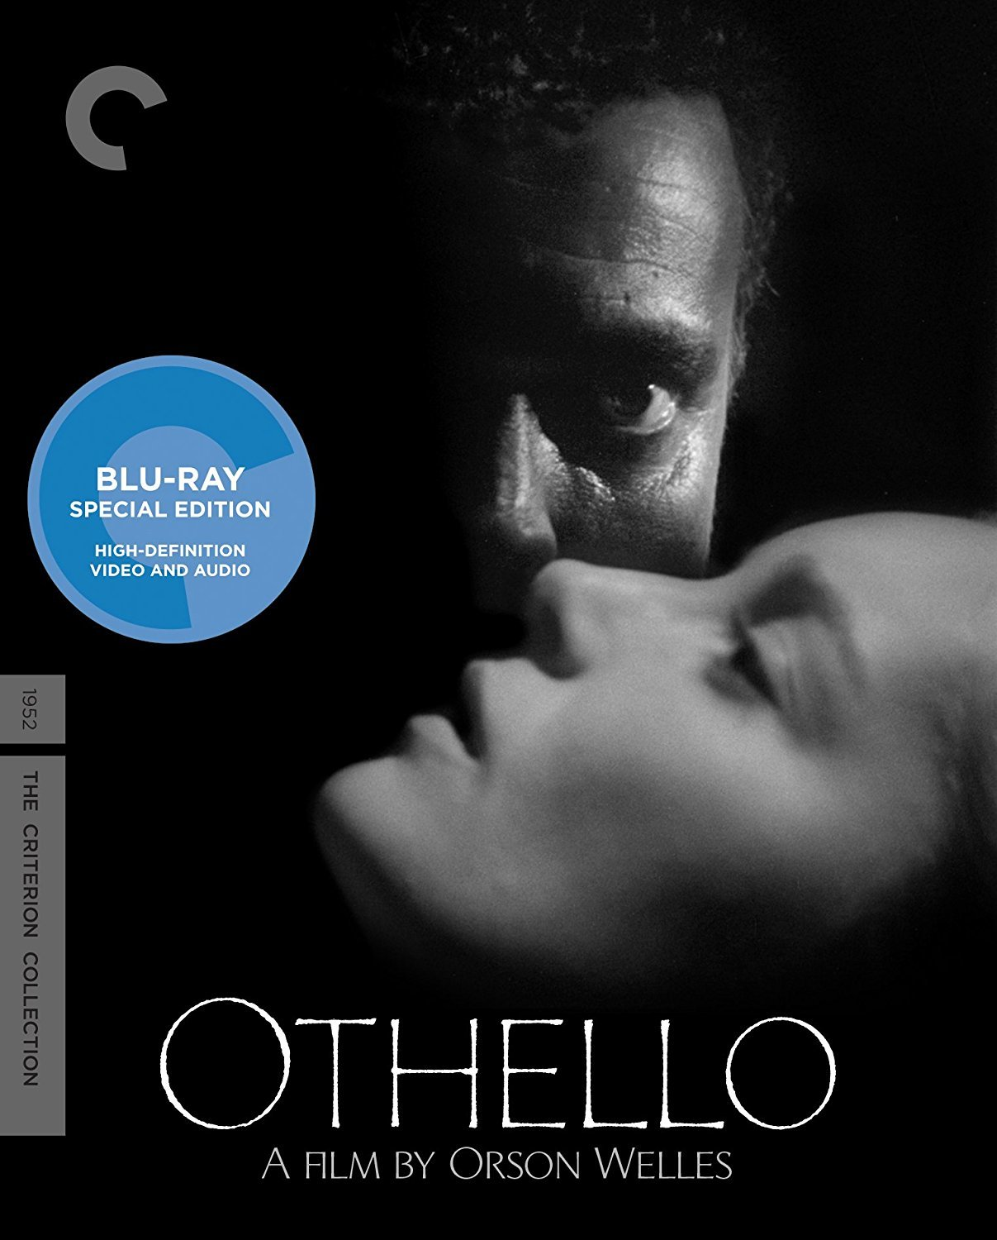
October 2017 Othello Blu-Ray DVD Cover
https://www.criterion.com/films/28621-othello
- Restoration of 4K digital transfers of the two 1952 European and 1955 U.S. and U.K. versions
- Composition: Entire cover is an image from the film where only part of Desdemona’s and Othello’s faces are shown. Desdemona is horizontal and her half-closed eyes imply a different state of consciousness and vulnerability. Just as only the left side of her face can be seen, only the left side of Othello’s face can be seen in the darkness though in a different way as he is looking directly at the audience and is vertical. Only one eye, his nose, and hair texture can be seen, and Othello looms behind Desdemona in a menacing position.
- Color scheme: One of the simplest color schemes on promotional material yet: the image is completely black and white as it is a screenshot from the movie, and the only other markings are the white text, gray production company labeling, and the blue Blu-Ray logo.
- Image choice: The image is a screenshot from the movie when Othello is approaching Desdemona to murder her. In this moment, Desdemona realizes that Othello is there, and Othello greets her.
- Font: The largest text is “Othello,” in thin white capital letters that almost appear to be scratched into the image. The medium white text is “A Film by Orson Welles,” and the production company and the Blu-Ray logo are in smaller text. Shakespeare is not accredited.
- Analysis: This DVD cover emphasizes the high definition video and audio, and this is the first promotional screenshot that makes Othello’s skin appear significantly darker than Desdemona’s. Othello appears predatory in this image, but in the film scene Desdemona is only pretending to sleep. However, that doesn’t eliminate Othello’s power over her, and this DVD cover seems to address the complex legacy of Welles’ blackface performance by emphasizing racial stereotypes that might captivate the audience’s interest As such, unlike the first re-release poster, this DVD cover doesn’t claim Orson Welles as a legendary director or the film as a lost classic, and this is the first cover since before the Cannes film festival award that doesn’t feature the award on it. It is simply “a film by Orson Welles,” without other significant text other than the title. The racial tension in the scene and high definition video and audio seem to be the main aspects used to draw in the audience. Shakespeare is again not credited, which is intriguing as this continues the pattern of Shakespeare being diminished or left off of promotional material into modern 2017.

Michelle Chen Shakespeare’s Global Afterlives
Ocular Proof: Orson Welles’ Visual Transformation of Othello and the Phenomenon of a Shakespearean Afterlife Without Shakespeare’s Ideas
Orson Welles’ 1951 Othello demonstrates the complexity behind globalizing
Shakespeare when a producer’s personal adaptation of a Shakespearean play overshadows the
Shakespearean traditions in the original source material. Welles changes the medium of the
original Shakespearean play in several ways both intentionally and unintentionally, such as
shifting Othello from the stage to film and budget limitations changing visual and audio aspects
from Welles’ original vision (Yagoda). Despite the discrepancies between the producer’s vision
and the final product, Othello’s promotion and reception changed over time in accordance with
the ideas audiences took away about the film’s association with Shakespeare and Welles. This
can be seen in the aspects of Welles’ vision that were not influenced by resource limitations and
appear in the final movie. Welles adapted the play to appeal to European audiences, and, later,
worldwide audiences (Bernad), by focusing on radically different ideas than what Shakespeare
suggests in the original source material. By cutting certain scenes and lines and expanding on
moments not present in the text, Welles caters to a wider audience by focusing on more
accessible humor that Shakespeare does not focus on in the play, emphasizing Othello and
Desdemona’s romance with at times melodramatic physical contact, and simplifying Iago’s
motivations and Othello’s social stigma (Crowther). As a result, Welles’ film takes on a life on
its own separate from Shakespeare as it focuses on popular film elements at the expense of
Shakespeare’s initial ideas to reach a wider audience. Just as Othello demonstrates an ideological
shift from Shakespeare’s text, so does its promotional material. Posters, DVD covers, and title
cards diminish or leave out Shakespeare’s name entirely in favor of language indicating Welles’
status as a storyteller and as the ultimate creator of the film. Shakespeare’s global afterlife in this
film takes on a life of its own disassociated with Shakespeare through Welles changing the
play’s medium and focus, which causes promotional material to cater to audiences’ desire for
novelty in a Shakespeare production and Welles’ prestige behind it. For Othello, the
Shakespearean play is not the main draw, but Welles’ transformation of the story.
One of the main elements that result in the film being innovative to the point where
Shakespeare’s influence is diminished is the change in medium from the stage to film, and the
according limitations Welles had with budget and resources. Several aspects of Welles’ original
vision are still present despite the limitations during filming. Describing an advantage Welles
had in choosing to film Othello over historical stage productions, Migual Bernad, a 1956 critic
of Welles’ Othello at a Philippine university, tells of “the close-up camera…Welles exploits to
the full. The camera records every reaction of the face: the flash of the eye, the flick of an
eyelash, the twitch of lip or cheek” (Bernad 7). Additionally, he states that the eavesdropping
scene where Othello tries to listen to Iago and Cassio is described as “splendid…usually
awkward on the stage” (Bernad 8). This demonstrates the increased emphasis on visual details
that comes with a film production of a Shakespeare play, which allows Welles to commodify the
story as one in his own tradition by prioritizing visual details over loyalty to the dialogue and
plot. A key motif in the film is mesh, which Welles explains as “one of Iago’s favorite
images…Our camera holds that image before your eyes and plays variations on it…the net that
holds [Desdemona’s] hair in Cyprus, the ships’ rigging…In the end Iago is caught in his own
mesh” (Gear 252). Welles is loyal to the famous line “With a little a web as this I shall snare the
great Cassio” (Shakespeare and Hall, 2.1.165-166), and emphasizes the symbolism of mesh in
the film, but at the expense of omitting other details behind Iago’s motivations present in the
text. Though Joseph McBride of the University of California states in a 1969 analysis of Othello
that Welles’ intention is not “to distort, attack, or ignore the text,” Welles says that he uses
“Shakespeare’s words and characters to make motion pictures. They are variations on his
themes.” Welles then compares his film to the 1887 opera Otello which he claims “certainly
could not have been written without Shakespeare, but it is first and foremost an opera. Othello
the movie, I hope, is first and foremost a motion picture” (McBride 13). As Orson Welles has a
historically innovative filmmaking style where, in his progression through adapting multiple
Shakespearean plays, has been “less and less faithful to [the Shakespearean] spirit as [Welles]
acquires more grace and confidence in uniting his own vision to Shakespeare’s” (McBride 13), it
is clear that Welles intentionally takes liberties with Shakespeare’s work, with the different
elements of film as opposed to the stage being one of Welles’ greatest inspirations in doing so.
Still, McBride justifies his argument that Welles does not completely disregard Shakespeare by
stating that Welles’ main concern with using the medium of film for Othello “is the question of
striking a stylistic balance between poetry and setting.” Unlike with Shakespeare’s original
medium, where most of the information is conveyed through dialogue due to the limitations of
staging in comparison to film, Welles understands that detailed imagery is one of the most
effective vehicles for storytelling in film. Since the inherent nature of film is that it focuses on
the visual, it is unavoidable that Shakespeare’s play is transformed, especially since Welles
“compensated for the cuts in the text with the condensation of visual images” (Bent 364). This
was not always successful, as Bernad states that “one of Othello’s lines during the street riot was
intended by Shakespeare to be “very impressive”…In the film the words are not impressive: they
are part of the chaos” (Bernad 11). As a result, this lessens Shakespeare’s influence in Welles’
Othello in accordance with Welles’ priorities of which aspects of Shakespeare are to be focused
on with motifs, which text is to be discarded without visual support, and which textual aspects
are unintentionally undercut by Welles’ visual choices.
The drastic medium shifts from Shakespeare’s original become more complex when the
unintentional medium changes in Othello from a tumultuous filming schedule and a crippling
budget are considered. Though it is debatable which aspects of the film Welles intended and
which occurred in the final version as a circumstantial budgeting result, because of similarities
between Welles’ own experimental filmmaking style and the film’s fragmented editing style
(Crowdus), all aspects of the final film determine Shakespeare’s afterlife for audiences and so
this distinction is not a significant factor in determining how Shakespeare does and does not
resonate through Welles’ Othello. In one of the first reviews for the initial film release, Bosley
Crowther in a 1952 edition of the New York Times critiques Othello’s poor audio quality which
causes Iago to be almost impossible to understand. Later, Gary Crowdus writes in the French
publication Cinéaste after the 1992 rerelease of an Othello with restored audio that the film is
characterized by “an extremely fragmented editing style… While the film's staccato rhythms
often complement the emotional or dramatic significance of a particular scene, they are just as
often disruptive and distracting. Many critics have esthetically rationalized this as Welles's self-
consciously "postmodernist" or "cubist" style, but a more prosaic and truthful explanation is that
Welles was merely attempting to disguise the low-budget production's more roughhewn
qualities.” Despite Welles’ intentions, the results demonstrate that Welles’ own take on Othello
influence the film far more than Shakespeare’s original story because of the film medium and
Welles’ priorities within that medium. Detailed visuals and editing techniques are unique to film.
The film’s visuals dominate the heavily-cut dialogue, which demonstrates why despite new
audio-remastered editions, reviews continue to emphasize visual effects. A 2017 review by J.
Hoberman in the New York Times, to promote the release of the latest 4K digital restoration of
Othello from Criterion on Blu-ray DVD, says, “Sound in “Othello” is always subordinate to
image. Less windy than windblown, it is a film full of jarring shifts, disorienting angles, and
sudden jumps to close-up — an expressionist style that let Welles accommodate all manner of
mismatched footage.” Intuitively, film audio corresponds to Shakespearean dialogue, which
comprises the majority of storytelling in the text of Othello. Whether intentional from the start or
worked into the film, Welles’ film only has a fraction of the text in Shakespeare’s
version. Because it was Welles’ personal choice to cut certain lines and scenes in favor of others
that worked well for the film medium’s dominant visual aspects, and because the visuals have
consistently outshined the audio in reviews even for modern DVD editions where the audio is
clarified, Othello is clearly Welles’ film and not Shakespeare’s play which shows how the story
has built a new afterlife based on the medium choices of its producer and not its original creator.
Another example of how Welles transforms Othello is by adapting the play to appeal to
modern moviegoing audiences through prioritizing accessible humor, increased romance, and
simplifying character motivations instead of conforming to Shakespearean tradition. Bosley
Crowther states in his New York Times 1955 review that “Shakespeare himself, set down before
it, might have a tough time recognizing his play. For the great Mr. Welles apparently
decided…that the text and even the plot of the original were incidental to the dark and delirious
passions enclosed in its tormented theme.” Othello’s sense of social stigma and Iago’s suspicion
that Othello is sleeping with his wife are “details and motivations that have been completely
overlooked by Mr. Welles. All that he seems to find intriguing are the currents of hate and
villainy.” In the film, the omission of these details stems from Welles’ usage of the film medium
to justify his decision to cut significant amounts of dialogue from the original play. As Welles
manipulates a medium foreign to Shakespeare, his heavy use of dark, atmospheric visuals in lieu
of text essential to the play conveys broader and vaguer strokes of ideas than the fine penciling
of verbal detail that Shakespeare incorporates. Because of the extreme textual cutting and focus
on a vague melodramatic visual mood, Iago’s manipulation of Othello seems absurdly quick
despite the large portion of screen time that focuses on his interactions with Othello, and Iago
appears unmotivated beyond a penchant for evil, which eclipses his complex motivations in the
text. As Geoffrey Bent states in his 1998 critique of Othello in an American literary journal,
“Welles's peculiar preference for the melodrama of fate dilutes the tragedy of the play…with
Othello the victim of impersonal fate rather than of personal failing, he comes across as far more
sympathetic. Welles opts for a heroic Othello, and consequently he plays down the racial aspect
of the character.” This breaks with major themes Shakespeare focused on in the play, namely
racial tensions and character complexity. Additionally, Welles focused on untraditional humor,
extending certain scenes that are offstage in Shakespeare’s text. A critique Bernad had in his
1956 review was how the film cut several dramatic scenes, such as when Othello kneels to make
his vow of vengeance and Desdemona sings the willow song, “one of the most beautiful passages
in all Shakespeare…the omission of this lovely scene from any production of Othello is
impossible to justify.” This was done partly in order to extend Welles’ own humorous scenes in
the film such as when Roderigo provokes Cassio and the mutiny plays out. This occurs at the
expense of Welles omitting “all the comical scenes in Shakespeare’s text” (Bernad 9). Another
element that Welles decided would take up more screen time than Shakespeare intended for stage
time in the text, therefore causing it to have a greater focus in the film than in the play, is
physical romance. Echoed in promotional material over time, most of which feature an intimate
interaction between Othello and Desdemona, Bernad praises “the soft-pedaling of the love
scenes” as a virtue of the film. This demonstrates the solid appeal of romance to the film’s
audiences over time, which is exaggerated beyond the boundaries of Shakespeare’s text to the
point of melodrama when in the film Othello begins kissing Desdemona through the sheet that he
is using to suffocate her. Finally, Welles simplifies concepts in the text itself through visuals that
humorously state the obvious, such as Iago carrying around a white dog whenever he interacts
with Roderigo and the camera cutting between Roderigo and the dog’s movements during the
scene when he attempts to murder Cassio which emphasizes that Roderigo is Iago’s lapdog.
Another scene that demonstrates this is when Othello immediately has his epileptic fit and falls
into a trance immediately after he states, “Farewell the tranquil mind” (Shakespeare and Hall,
3.3.365) as part of a heavily cut soliloquy and one that contradicts the order of Shakespeare’s
plot. The immediate physical association between lapdog and Roderigo, and a disturbed mind
with an epileptic trance, is a much simpler way to entertain Welles’ audience than the
entertaining elements Shakespeare included within the text for his own audience. As a result,
Welles’ innovations catered to a broad, popular audience by diverting from Shakespearean
tradition insofar as changing Othello’s focus from Shakespeare’s own major themes in the play
to elements that would cater to a modern audience using simplicity, untraditional humor, and
melodramatic romance. This ultimately transforms Welles’ Othello into something drastically
un-Shakespearean in terms of the major ideas Shakespeare prioritized in the play.
Another indicator of Othello’s shift away from its Shakespearean source material is in the
designs of the film’s promotional material. Posters, DVD covers, and title cards over time, for
both the original film and future edited versions, either diminish or do not credit Shakespeare.
Instead, Welles’ reputation is typically magnified in promotional text – exceptions are the first
1952 Italian promotional poster and the most recent 2017 DVD cover for the Criterion’s
remastered Blu-ray version. First reactions to the film may have heavily influenced this
promotional decision, as Othello was derided as “just a little Shakespeare and a lot of Welles,”
(Crowther), “seriously handicapped…by extreme budgetary restrictions and a resulting
crudeness of tone” (McBride 13), and was not highly anticipated as seen in Bernad’s review
where “[Welles’] other films had betrayed a mania for trick photography and a partiality for the
spectacular and even the grotesque, which caused many a lover of Shakespearean tragedy to
conceive the devout wish that Mr. Welles would leave Shakespeare alone.” These early reviews
by Crowther, McBride, and Bernad between 1955 and 1969 focus on comparing Welles’ Othello
with details in the original text, demonstrating audiences’ initial commitment to Shakespearean
accuracy. Additionally, “the Golden Palm [award] meant little to a moviegoing public
uninterested in black-and-white Shakespearean adaptations, and "Othello" did its quick
disappearing act. Over the years, however, the film acquired a lofty reputation, as the first (and
possibly most) purely cinematic version of Shakespeare ever” (Yagoda). Paired with promotional
text after the first reception that implied Welles’ full ownership over the Othello story in his film
and continued to emphasis his status as a film director, the reemergence of Othello coincided
with audience expectations after their first shocking exposure to the film as one that contradicted
beliefs about a film adaptation’s loyalty to the Shakespearean text. Hailed as an innovative
“masterpiece” from “one of America’s greatest directors” on the US re-release poster for the first
complete restoration, Shakespeare has no place on the poster. Welles’ elevated status through
the prominent Cannes film festival award and taglines on the promotional material allows him to
replace Shakespeare as the ultimate director of an Othello that is popular without regard to
Shakespeare’s intentions as to the main ideas of the play. Because of this, the afterlives of
Shakespeare’s plays can be reevaluated in terms of a director’s influence on public perception as
well as through medium and ideological shifts away from the text. While the first promotional
reviews complained about Welles’ breakings with Shakespeare’s play, with the title of the first
New York Times review being Orson Welles Revises 'Othello'; Scraps Shakespeare's Plot for
Visual Effect,” later reviews in 1992 and 2017 promoting the re-releases are titled “Welles's
'Othello' Made Chaos Into an Art Form” and “Shakespeare’s Tragedy was Orson Welles’
Greatest Triumph.” This shift in perspective of the quality of a radical Shakespeare adaptation
occurs despite Welles’ own misgiving in excerpts from his 1979 documentary, Filming Othello,
where “he clearly bemoans having to discuss his admittedly compromised film when he would
really rather be discussing his plans for a future production of Othello which, he assures us,
would be "one hell of a picture” (Crowdus). Welles’ Othello therefore takes on a life on its own
over time – first in comparison to Shakespeare, then as within Welles’ creative control, then
finally still within Welles’ creative control but disregarding the director’s own perception of the
film. Peter Keough of the Boston Globe promotes the 2014 US Carlotta restoration of Othello as
“if not his best film, then his most uncanny and perhaps his most perfectly realized” and as
“beginning with the ending, the narrative then follows that of the original, but so truncated and
abruptly pieced together that it takes on an alien quality.” The full, accurate story of Othello as
Shakespeare put down appears to be unappealing to modern audiences, and it becomes clear that
one of the main draws of a Shakespeare production is novelty. Paired with the innovative Welles,
the film gathered acclaim over time for its substantial alterations from the Shakespeare play
and not despite its breakings with Shakespearean tradition. The film is clearly Welles’ Othello,
and not Shakespeare’s Othello, and modern worldwide audiences appear to take that to heart
from the film’s promotional material, which revived substantial interest and praise. Shakespeare
is increasingly invisible in Othello’s posters and other promotional material, which demonstrates
that audience interest in the film is based on Welles’ innovative choices in making Othello his
own. As a result, Shakespeare’s global afterlife in Welles’ Othello takes on a life of its own
disassociated with Shakespeare in accordance with the audiences’ conception of the film through
promotional material. The acceptance of globalized Shakespeare is eventually independent of
adherence to Shakespearean tradition in Othello. This demonstrates that the dynamic
relationships a Shakespearean adaptation has with its audiences and director and the reputation it
builds can be more important to a play’s afterlife than Shakespeare’s influence in the adaptation.
In Orson Welles’ 1951 Othello, the Shakespearean source material is eclipsed by the life
the film develops through the medium, the director’s ideas, and promotional items’ designs. The
importance of the film’s visuals as atmospheric stand-ins for omitted textual details of the play
results in a film that is more influenced by Welles’ decisions than Shakespeare’s Othello. Both
Welles’ intentional and improvised visuals alter the medium of the film further from the original
play by emphasizing visuals over dialogue, and while at first the hesitant reception to Othello
was primarily due to a lack of integration with the public’s vision of a well-known play’s textual
details, over time the innovative aspects of Welles’ filmmaking and his increasing reputation for
innovation has allowed Welles to replace Shakespeare as the creator of his own popular version
of Othello. As a result, the radical ideas Welles choose to focus on, such as enhanced physical
romance, untraditional humor, and simplified characters and methods of engaging the audience,
draw in a worldwide audience without the influence of Shakespeare. The original Shakespearean
plot and story became less essential in attracting audiences than the novel approach Welles uses
with Othello, apparent in how the designs of promotional material for multiple versions of the
film diminish the influence of Shakespeare’s ideas in the film. Welles’ personal adaptation
overshadows many traditional major ideas, mediums, and aspects used to promote an audience
that Shakespeare suggests in the source material, and Welles’ bravura creates a greater audience
for Othello as a result. Thus, Welles’ transformation of Othello is complete and successful as the
film ultimately provoked all the historical popularity associated with Shakespeare’s original
work despite the film’s innovative disassociation with Shakespeare’s original intentions.
Through Orson Welles’ Othello, it is clear that when considering Shakespeare’s global afterlives,
the impact of ocular proof cannot be denied – by incorporating novel imagery and visual ideas
into a film and its corresponding promotional material, a director and a willing modern audience
can have a greater impact on the dynamic life of a Shakespearean adaptation than Shakespeare
himself.

Bibliography

Bent, Geoffrey. “Three Green-Eyed Monsters: Acting as Applied Criticism in Shakespeare's
‘Othello.’” The Antioch Review, vol. 56, no. 3, 1998, pp. 358–373. JSTOR, JSTOR,
www.jstor.org/stable/4613714.

Bernad, Miguel A. “Othello Comes to Town: Orson Welles and Edmund Kean.” Philippine
Studies, vol. 4, no. 1, 1956, pp. 3–14. JSTOR, JSTOR, www.jstor.org/stable/42719194.

Crowdus, Gary. “Review of Othello by Orson Welles.” Cinéaste, vol. 21, no. 4, 1995, pp. 52–
52. JSTOR, JSTOR, www.jstor.org/stable/41687428.

Crowther, Bosley. “Screen: Orson Welles Revises 'Othello'; Scraps Shakespeare's Plot for
Visual Effect - NYTimes.com.” Movie Reviews, Showtimes and Trailers - Movies
- New York Times - The New York Times, 13 September 1955, movies.nytimes.com/
movie/review?res=9501E7DF123FE43ABC4B52DFBF66838E649EDE.

Gear, Matthew Asprey. “TO ADORE THE IMPOSSIBLE.” At the End of the Street in the
Shadow: Orson Welles and the City, Columbia University Press, 2016, pp. 243–
256. JSTOR, www.jstor.org/stable/10.7312/gear17340.18.

Hoberman, J. “‘Othello’: Shakespeare’s Tragedy Was Orson Welles’s Triumph.” The New York
Times, 29 September 2017, www.nytimes.com/2017/09/29/movies/othello-orson-
welles.html.

Keough, Peter. “Orson Welles’s ‘Othello’: Moor! Moor! Moor!” BostonGlobe.com, Critic’s
Notebook: The Boston Globe, 26 June 2014, www.bostonglobe.com/arts/movies/
2014/06/26/critic-notebook-orson-welles-othello/nKSSkXDSuL0YUpTYy93xCM/
story.html.

McBride, Joseph. “Welles's Chimes at Midnight.” Film Quarterly, vol. 23, no. 1, 1969,
pp. 11–20. JSTOR, JSTOR, www.jstor.org/stable/1211102.

Shakespeare, William, and Kim Hall. Othello, the Moor of Venice: Texts and Contexts. Palgrave
Macmillan, 2007.

Yagoda, Ben. “Welles's 'Othello' Made Chaos Into an Art Form.” New York Times, 1 March
1992, www.nytimes.com/1992/03/01/movies/film-welles-s-othello-made-chaos-into-an-
art-form.html.

